Access to the Brighton Centre
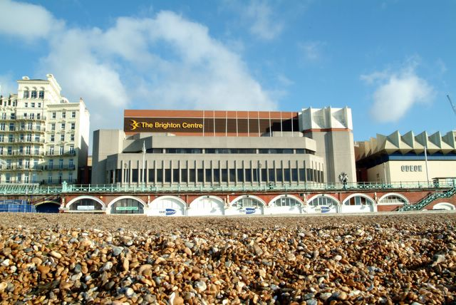

Booking Tickets & Accessible Seating
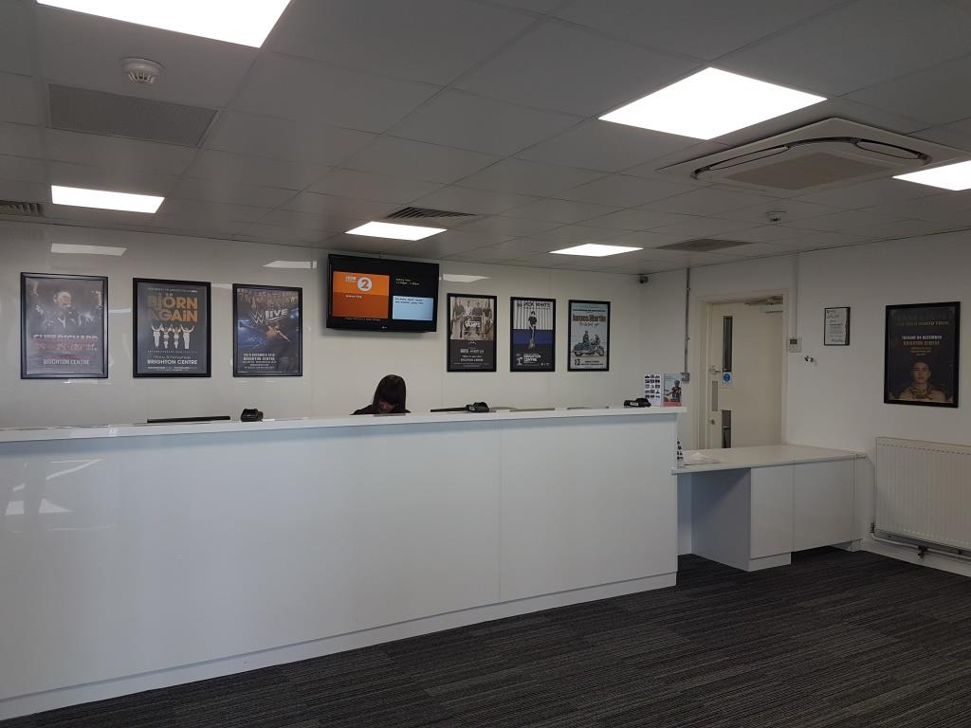  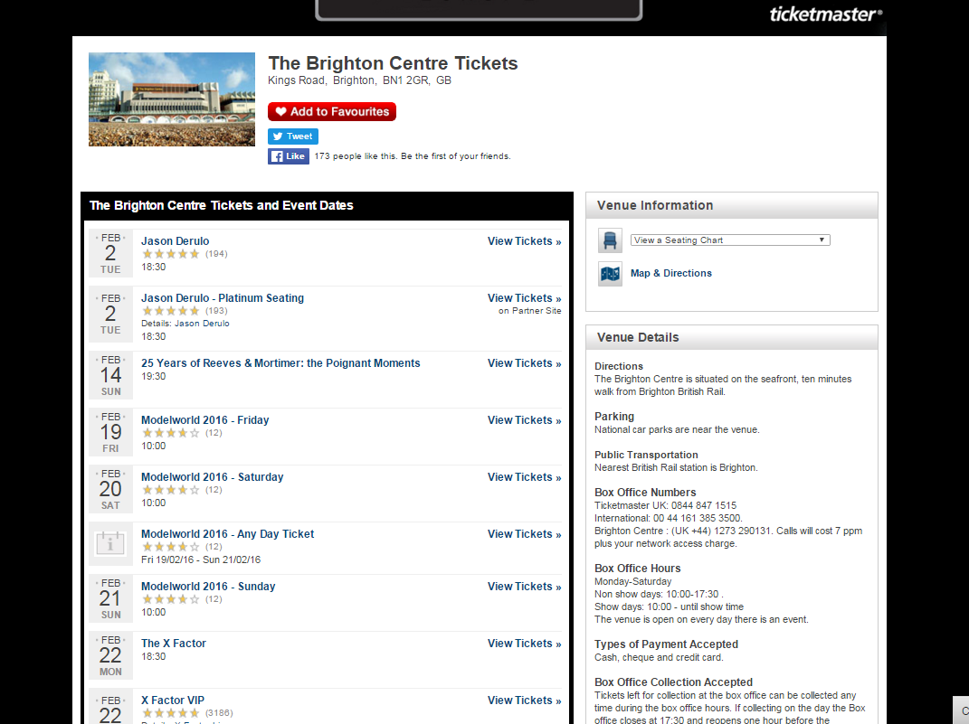 |  | You can book tickets by going into the Brighton Centre Box Office or on the Ticketmaster website  Use this link: http://bit.ly/1MVheri
If you need accessible seating or a free companion ticket, please call:
01273 292 695
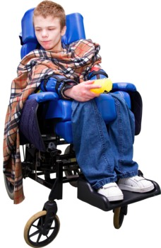 |  | There are some wheelchair spaces. Call as early as you can to book these
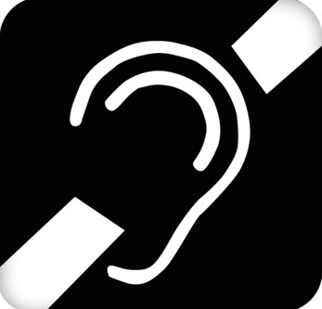 |  | If you are Deaf or have trouble hearing we have a hearing loop in the auditorium.  For details call 01273 292 695, you can use Relay UK -  or email brightoncentre@brighton-hove.gov.uk
If you are blind or have trouble seeing you might be able to have a seat closer to the stage.
Call 01273 292 695 before you book tickets to ask about this

- How Can I Access the Box Office
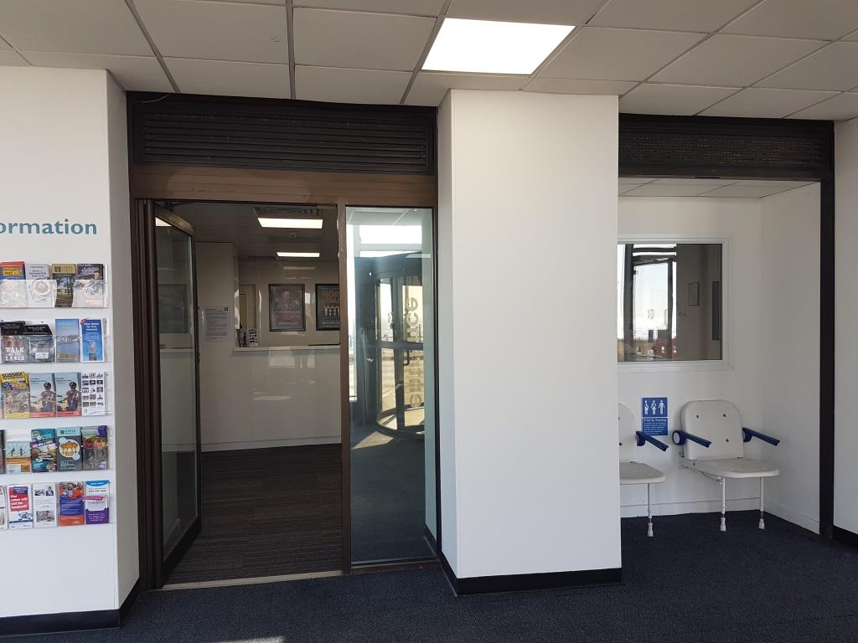  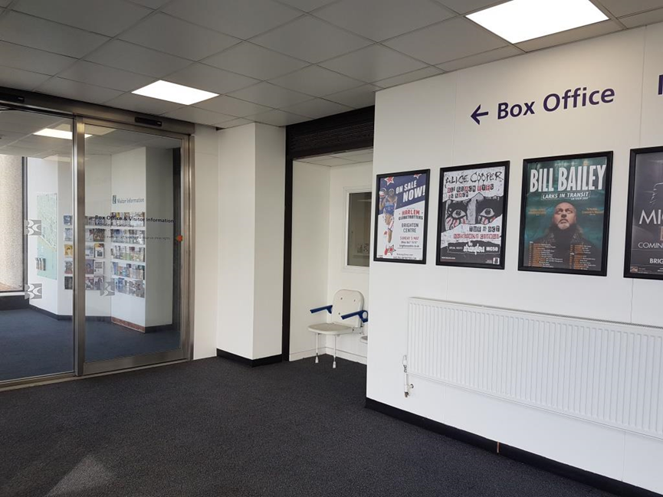 |  | The Box Office is on the ground floor at the front of the venue and is fully accessible:
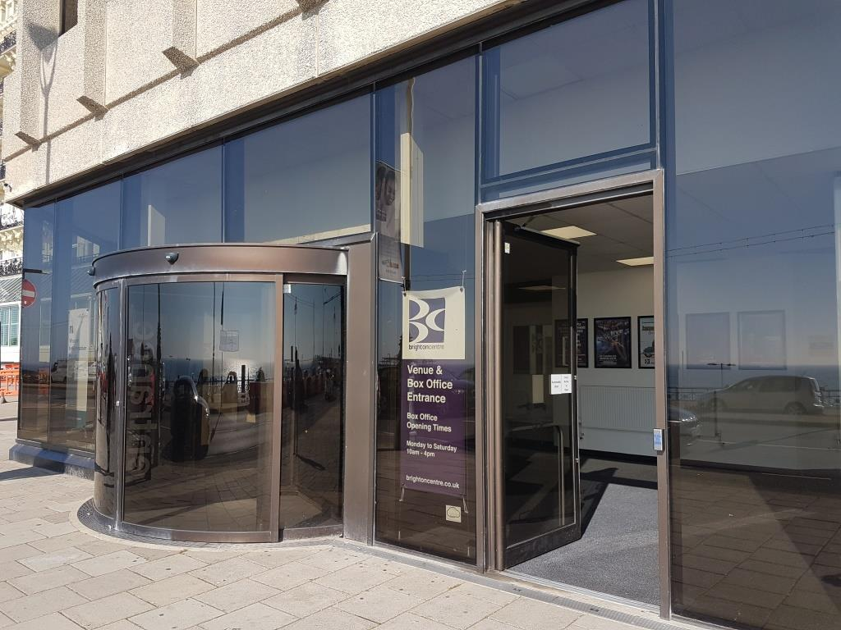 |  | A flat door
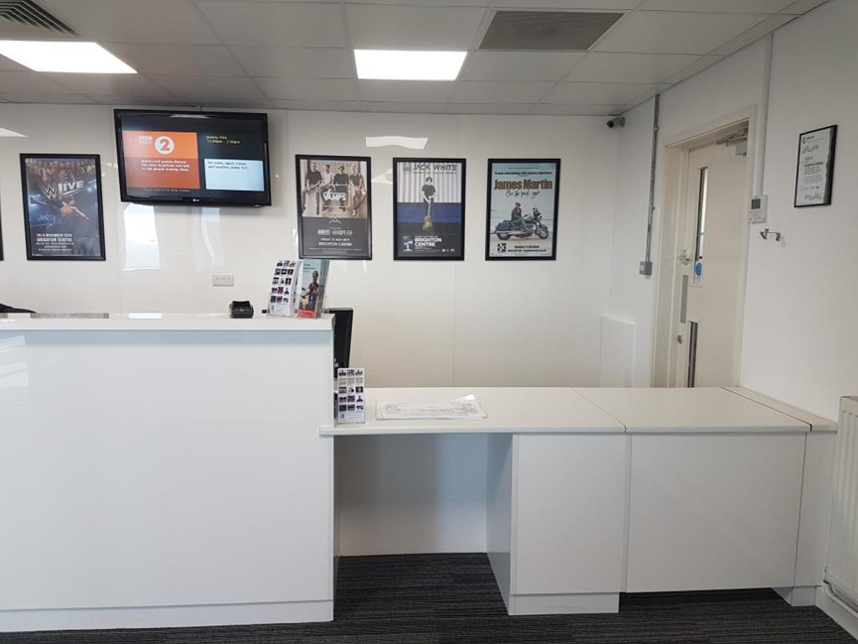 |  | A low level counter
 |  | Information in large type on request
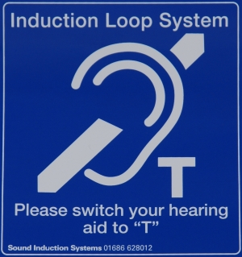 |  | An induction loop
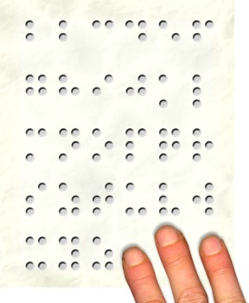 |  | Information in Braille on request – this needs to be requested in advance and you may have to wait for it to be done
 |  | A magnifying glass
- Getting to the venue
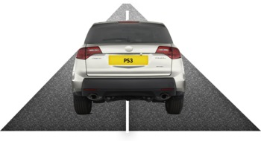  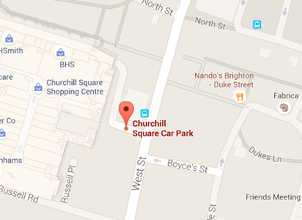 |  | Parking  The nearest public car park is Churchill Square Car Park, BN1 2FB  The entrance to the car park is via West Street
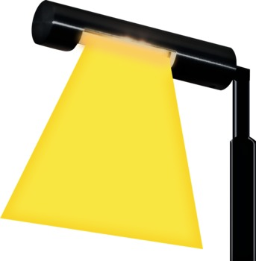 |  | Lighting in the car park is good
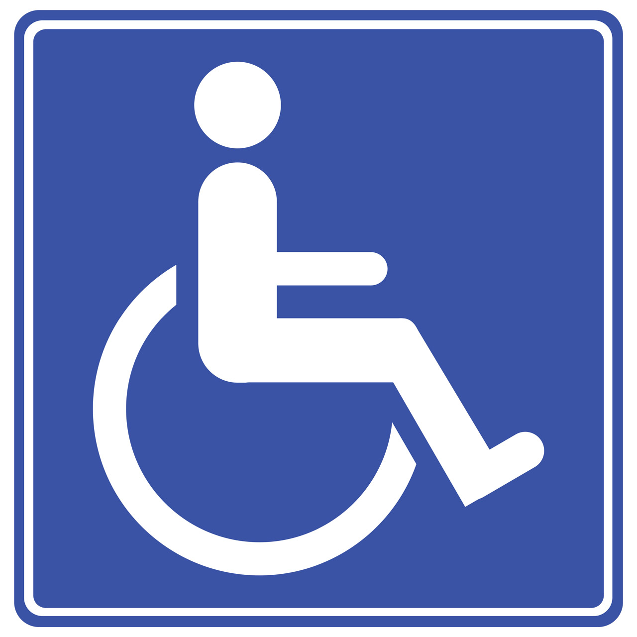 |  | There are disabled parking spaces in the car park
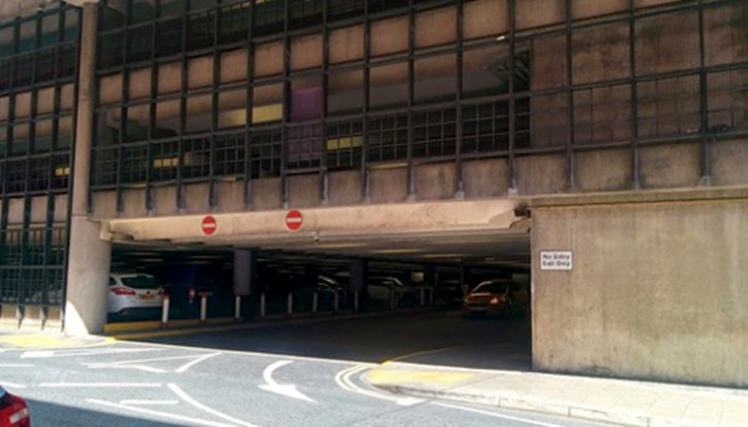 |  | The distance from the car park exit to the venue is approximately 30 metres
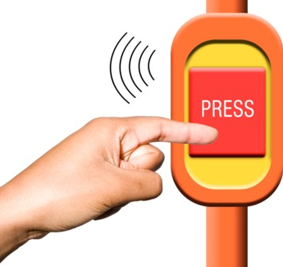 |  | If you need help to pay press the call button
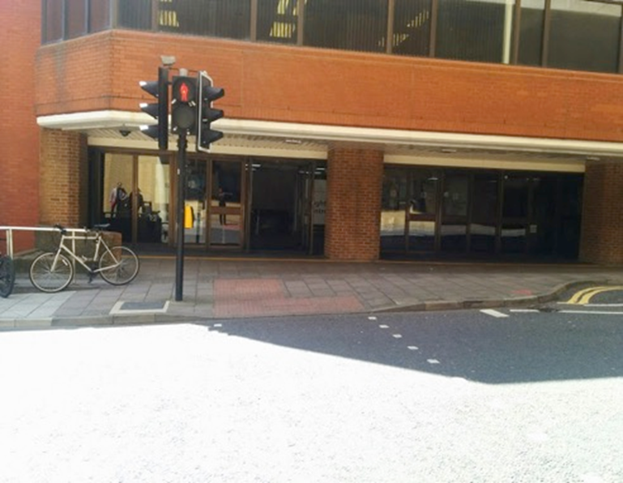 |  | There is level access across the road
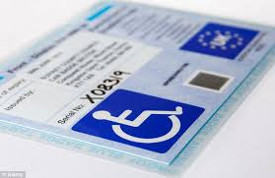 |  | Blue Badge parking and drop offs  There are Blue Badge parking bays close to the venue on West Street.
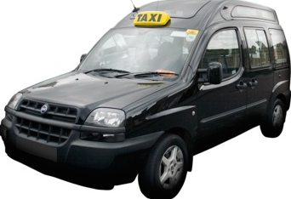  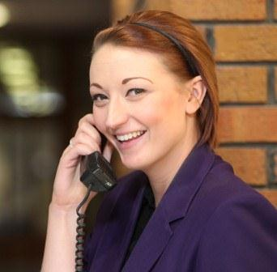 |  | Taxis  If you need to book an accessible taxi we recommend:  City Cabs:  Tel 01273 205205  Brighton and Hove Radio Cabs:  Tel 01273 204060  Streamline Taxis: Tel 01273 202020  There are free taxi phones that can be used to call a taxi inside the venue.  A member of staff can call for you.
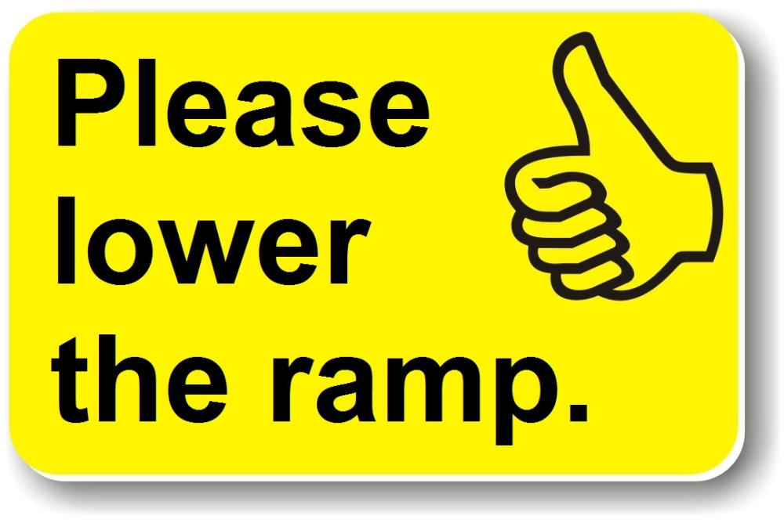  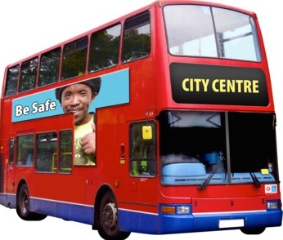 |  | Buses  The nearest bus stops are outside Churchill Square shopping centre, which is up the hill.  City buses are accessible. You can use a ‘Helping Hand’ card to tell the driver your needs. To get a yellow card use this link: https://www.buses.co.uk/helpinghand
- Getting into the venue
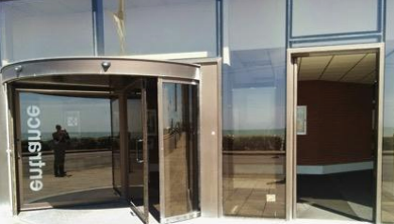 |  | You can get into the Brighton Centre via:  The front entrance on Kings Road  From here there are lifts to take you to all the floors
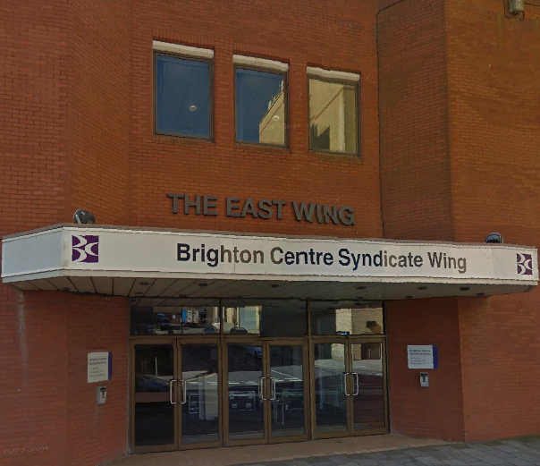 |  | The rear entrance on Russell Road From here there are lifts to take you to any floor  You can also access the Syndicate Wing here.
Getting around the venue

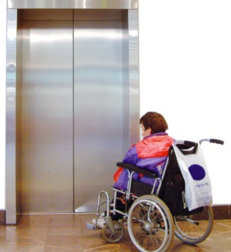 | You can get around the Brighton Centre by using the lifts
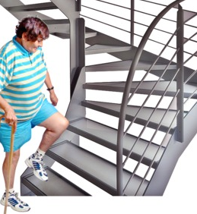 | You can also use the stairs  In the Auditoriums, Stewards can help you get to your seat
We have an accessible map.

Use this link to download the map

brighton-centre-access-map.pdf (brightoncentre.co.uk)

Accessible Toilets
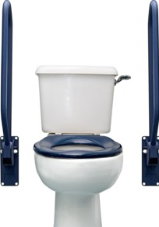 |  | There are accessible toilets on all floors

Food and Drink
There are two main bars next to Auditorium 1
They have low counters at one end
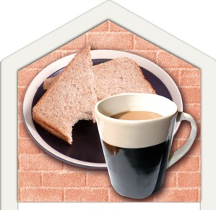 | There is a café next to the Box Office that sells hot and cold food  You can ask for a menu written in large font

- Assistance Dogs
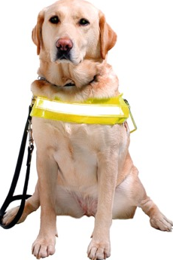 | You can bring your assistance dog to the Brighton Centre  Our staff can look after the dog when you are watching the show
- Sound levels & strobe lighting
 | The Brighton Centre can’t change how loud a show is, but if you ask they can give you earplugs
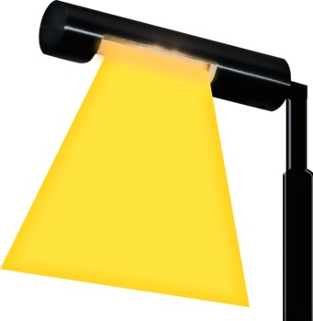 | Some shows will have smoke and strobe lighting  You can call and ask before the show if you are worried about this
Emergencies

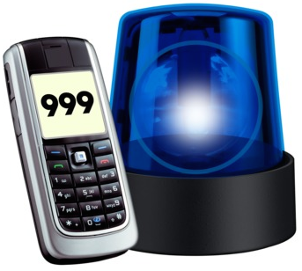 | If there is an emergency, there will be flashing lights and an alarm  Stewards will take you outside
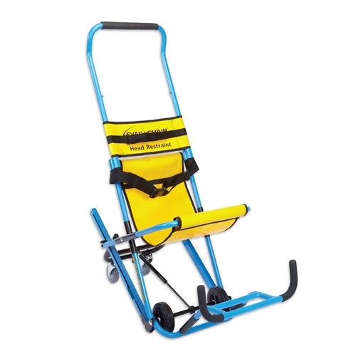 | If you need to use an evacuation chair the staff can help you and you can ask them
Medical Assistance & Respite Space
 | If you are ill, you can tell a steward and they will go and find someone to help you
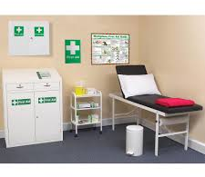 | There is a First Aid Room where you can go if you are ill.  You can ask a steward to take you there
There is a Respite Space if you want some quiet time

You can ask stewards to take you there
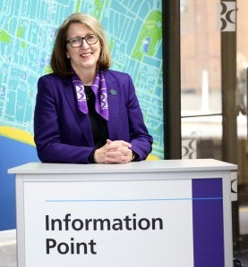 | If you are worried or need help please speak to a steward who will help you

Feedback and Contacting the Brighton Centre
If you have any questions, want to tell somebody how you feel about this report or about access at the Brighton Centre you can:

Call us:
01273 292 695

Email us: brightoncentre@brighton-hove.gov.uk

Send us a letter:
Brighton Centre
Kings Road
Brighton, BN1 2GR
Or come to see us at the Box Office, we would be happy to see you
Published: August 2023
Review Date: August 2024

